Supplementary Material
Exploring slip partitioning in the Southern Andes: New insights from fault slip data and crustal seismicity
José Cembrano, Alain Lavenu, Constanza Rojas, Pablo Iturrieta, Nicolás Pérez-Estay, Ashley Stanton-Yonge, Javiera Ruz-Ginouves, Pamela Pérez-Flores, Gerd Sielfeld, Gabriela Zañartu, Rebecca Pearce, Almudena Sánchez de la Muela, Tomás Roquer, Isabel Santibáñez, Tiaren García, Flavia Rojas, Pablo Sánchez, Simone Masoch, Thomas Mitchell, Gloria Arancibia, Ashley Griffith, John Browning, Karin Hofer, Gonzalo Yáñez
- Catalog compilation
To identify and classify the seismicity distribution along the Southern Andean margin, we compiled focal-mechanism solutions from Global CMT (Ekström et al., 2012) and ANSS-ComCat (U.S. Geological Survey, 2017) into a unified schema, using nodal planes or full moment tensors when available. We show the events’ double-couple component and its classification in figure S1. We filtered to southern Chile ($-80°≤lon≤-65°$, $-51°≤lat≤-31°$, $depth≤150 km$), and from 1976-01-01 to 2025-08-01. Duplicates were identified using a time-distance-magnitude search window (e.g., Weatherill et al., 2016) with $\left|Δt\right|≤120 s$, $\left|ΔR\right|≤80 km$, and$\left|ΔM\right|≤0.8$. For each cluster, we chose one source by preference (ANSS-ComCat first), falling back to the other catalog if the preferred record had a placeholder depth (e.g., 33 km), a missing or default focal mechanism. Non-duplicate events (present in only one catalog) or clusters with $N≥2$ (e.g., short-term aftershocks) were reviewed manually. Because depth often has large uncertainty, we used a relocated hypocentral catalog when available (Potin et al., 2025) to refine event locations.
Different classification rules are applied depending on the horizontal location of an earthquake, which we describe from west to east. If an event lies west of the subduction trench, then it is immediately classified as outer-rise. Immediately eastward, along the footprint of the subduction interface, events can be classified as either interface, forearc or intra-slab. We used the Slab2 geometry of Hayes et al. (2018) to check the event’s hypocenter relative to the subduction interface. The interface is assumed to be located where the top surface of the slab is shallower than 70 km, although this could vary across latitudes (particularly in the vicinity of the flat slab at 32° S). However, we argue this choice is not impactful, since our classification placed 95% of interface events below 45 km depth.
We aim to provide a conservative classification, where forearc (and intra-slab) labels are assigned only if they meet strict criteria. First, the event depth $d$ (positive downwards) is compared to the minimum slab interface depth ${d_{s }}^{min}$ at the event’s horizontal error ellipse. If $d+ε≤{d_{s }}^{min}-Δ$, where $ε$ is the reported event’s depth error and $Δ$ is an arbitrary buffer, then the event is classified as forearc. If, on the other hand, $d-ε ≥ {d_{s }}^{max}+Δ$, where ${d_{s }}^{max}$ is the maximum slab interface depth at the event’s horizontal error ellipse, then the event is classified as intra-slab. To set a conservative criterion, we define $Δ=7 km$ when non-zero depth/location errors are available; otherwise $Δ=15 km$. Events within the subduction interface buffer (i.e., not meeting previous classification rules) undergo a kinematic check, that is, to determine whether a focal mechanism is compatible with subduction solutions. Events are classified as interface if: (1) one of the nodal-plane normals lies within 35° of the slab normal at its location, and (2) the slip vector is within a range defined by the convergence vector and the margin-orthogonal component, both projected onto the nodal plane, allowing a 10º buffer to each side. Otherwise, they are classified as forearc or intra-slab if $d≤d_{s}$ or $d>d_{s}$, respectively.
East of the subduction interface, events are classified as deep intra-slab if $\left|d-d_{s}\right|≤15$. Shallow crustal intra-arc events are those within the main cordillera footprint, with depths shallower than 40 km, whereas deep intra-arc events lie below that threshold. Back-arc events lie east of that footprint, with $d≤60$. It is worth mentioning that the magnitude of completeness (i.e., the lowest possible magnitude above which all events are recorded) varies greatly over time and space across the analyzed decades (Di Giacomo et al., 2015); thus, variations in seismicity rates can be unrepresentative. However, we mostly focus on the kinematics across different crustal domains. The P- and T-axes of all events are shown in figure S2, grouped by their corresponding tectonic region.
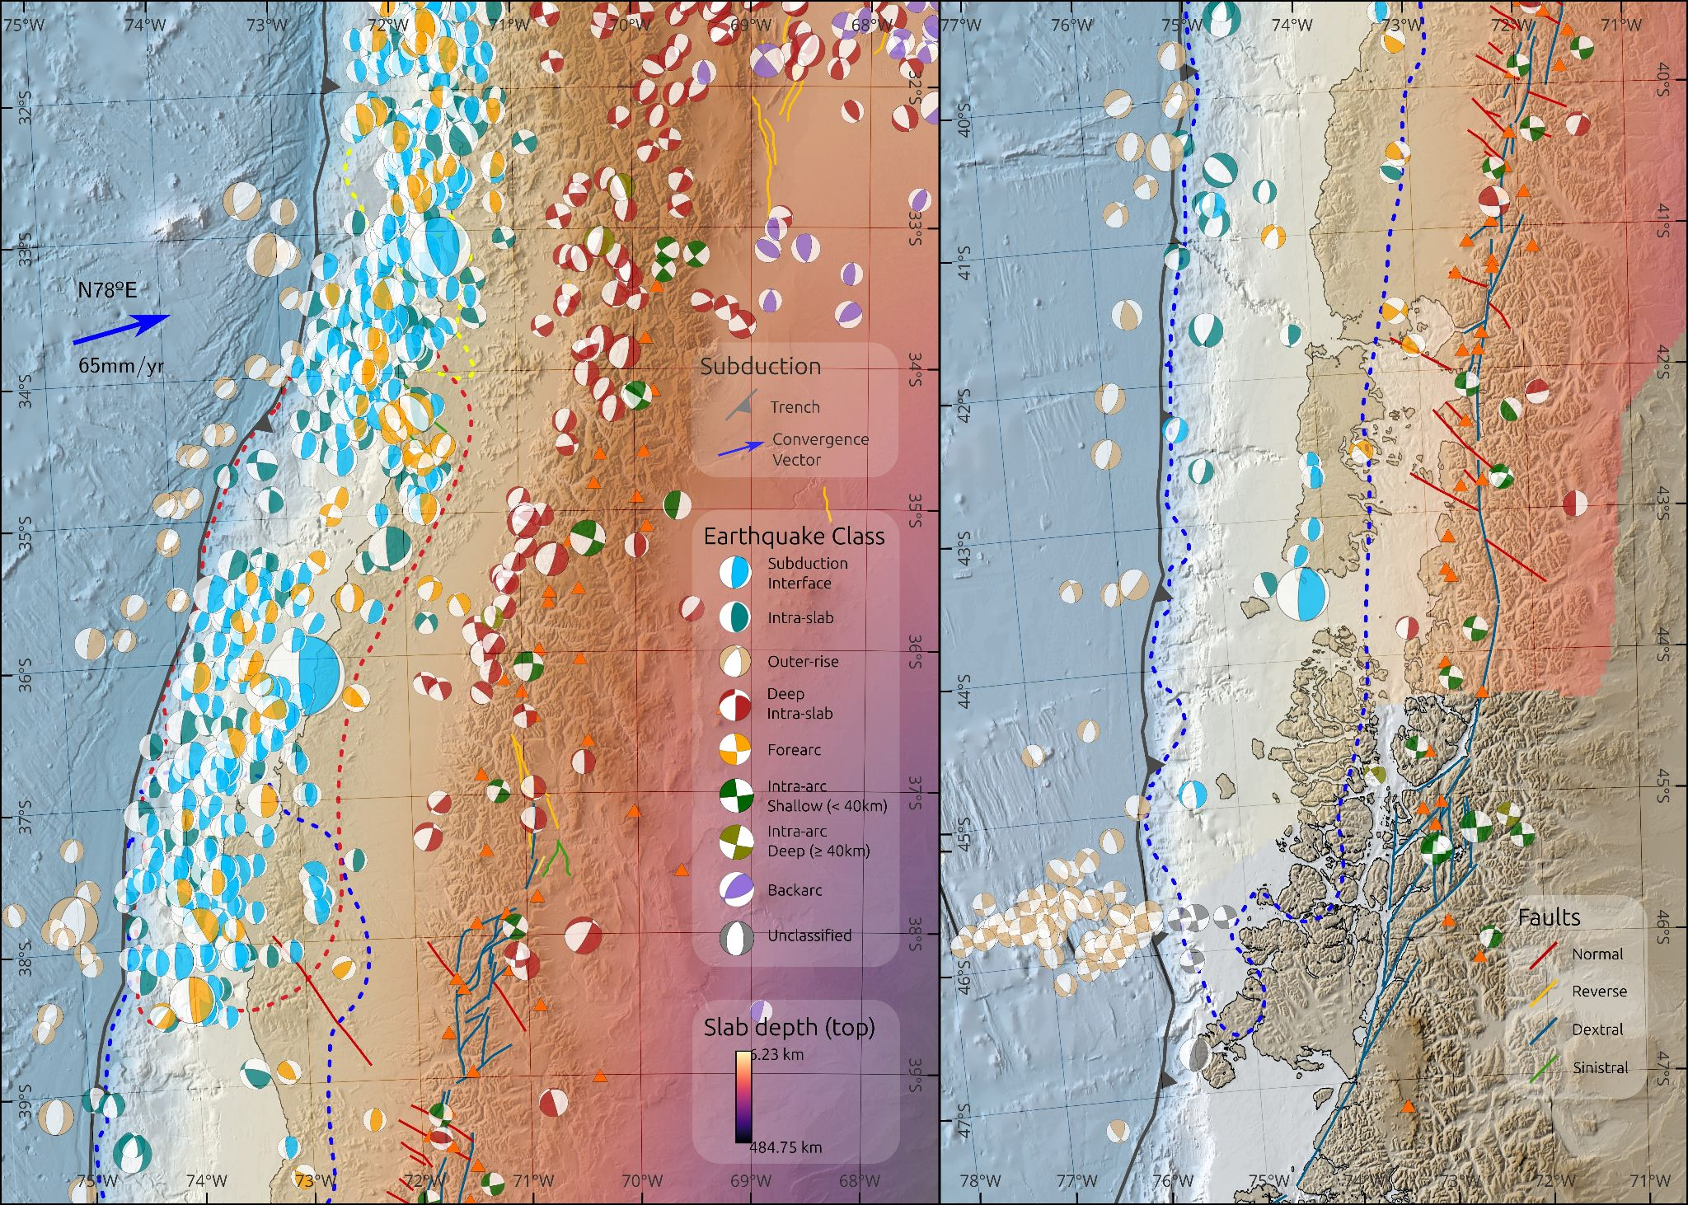
Fig. S1. Complete classified catalog for the Southern Andes for multiple earthquake types. The depth of the slab top surface (Hayes et al., 2018) and the SARA compilation of Quaternary faults (Santibáñez et al., 2018) are also shown. The segmented blue line represents the 1960 Valdivia${ M}_{w}=9.5$ earthquake rupture zone, with slips larger than 1 m (Moreno et al., 2012), the red line represents the 2010 Maule $M_{w}=8.8$ earthquake, and the yellow line the 1985 Valparaíso $M_{w}=8.0$ earthquake (Bravo et al., 2019).

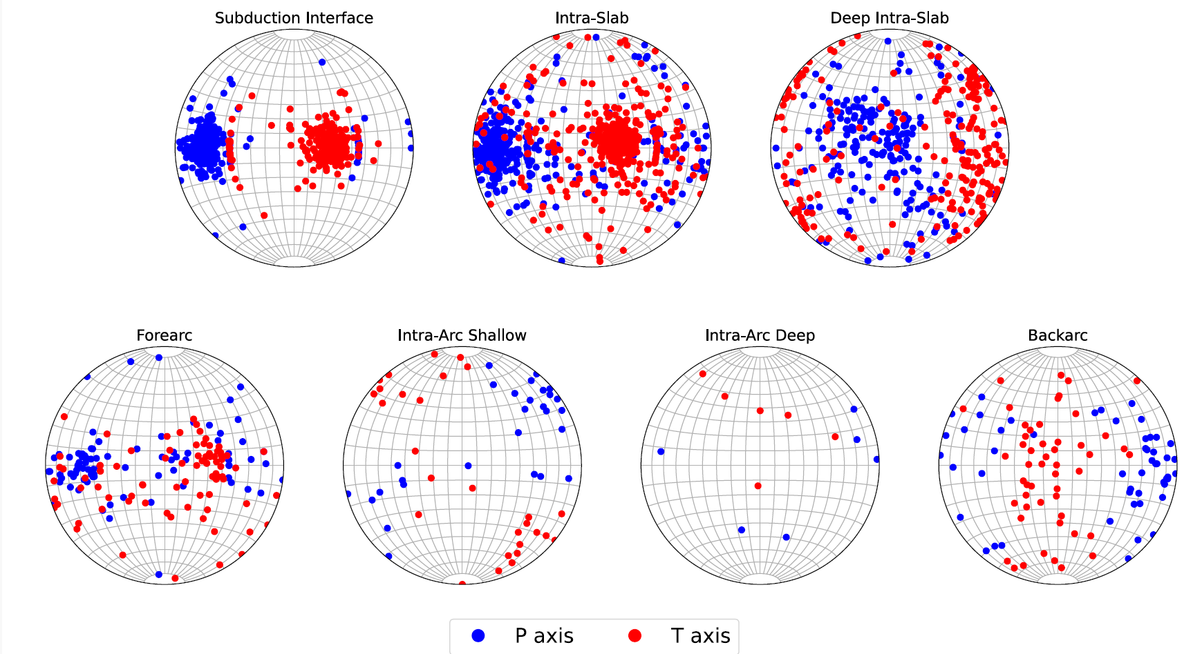
Fig. S2. P- and T-axis directions of the regional seismicity, classified according to their location within the subduction context. See text for details and figure S1 for the corresponding map view.

- References

Bravo, F.; Koch, P.; Riquelme, S.; Fuentes, M.; Campos, J. 2019. Slip distribution of the 1985 Valparaíso earthquake constrained with seismic and deformation data. Seismological Research Letters, 90 (5): 1792-1800. https://doi.org/10.1785/0220180396
Di Giacomo, D.; Bondár, I.; Storchak, D.A.; Engdahl, E.R.; Bormann, P.; Harris, J. 2015. ISC-GEM: Global Instrumental Earthquake Catalogue (1900–2009), III. Re-computed M_{S} and m_{b}, proxy M_{W}, final magnitude composition and completeness assessment. Physics of the Earth and Planetary Interiors 239: 33-47. https://doi.org/10.1016/j.pepi.2014.06.005
Ekström, G.; Nettles, M; Dziewońsk, A.M. 2012. The global CMT project 2004–2010: Centroid-moment tensors for 13,017 earthquakes. Physics of the Earth and Planetary Interiors 200: 1-9. https://doi.org/10.1016/j.pepi.2012.04.002
Hayes, G.P.; Moore, G. L.; Portner, D. E.; Hearne, M.; Flamme, H.; Furtney, M.; Smoczyk, G.M. 2018. Slab2, a comprehensive subduction zone geometry model. Science 362 (6410): 58-61. https://doi.org/10.1126/science.aat4723
Moreno, M.; Melnick, D.; Rosenau, M.; Baez, J.; Klotz, J.; Oncken, O.; Tassara, A.; Chen, J.; Bataille, K.; Bevis, M.; Socquet, A.; Bolte, J.; Vigny, C.; Brooks, B.; Ryder, I.; Grund, V.; Smalley, B.; Carrizo, D.; Bartsch, M.; Hase. H. 2012. Toward understanding tectonic control on the Mw 8.8 2010 Maule Chile earthquake. Earth and Planetary Science Letters 321-322: 152-165. https://doi.org/10.1016/j.epsl.2012.01.006
Santibañez, I.; Cembrano, J.; García-Pérez, T.; Costa, C.; Yáñez, G.; Marquardt, C.; Arancibia G.; González, G. 2019. Crustal faults in the Chilean Andes: geological constraints and seismic potential. Andean Geology 46 (1): 32-68. http://dx.doi.org/10.5027/andgeoV46n1-3067
U.S. Geological Survey (USGS). 2017. Advanced National Seismic System (ANSS) Comprehensive Earthquake Catalog. https://earthquake.usgs.gov/data/comcat/
Weatherill, G. A.; Pagani, M.; Garcia, J. 2016. Exploring earthquake databases for the creation of magnitude-homogeneous catalogues: tools for application on a regional and global scale. Geophysical Journal International 206.3: 1652-1676. https://doi.org/10.1093/gji/ggw232

